**2. Create table given below: Employee and IncentiveTable**

**Table 1 : Employee**

Create table employee(

Employee_id int primary key auto increment not null,

First_name varchar(20),

last_name varchar(20),

salary bigint , joining_date varchar(50) ,

department varchar(20)

);

insert into employee(First_name, last_name , salary,joining_date, department)VALUES

("johan", "Abrahan" , 10000000 ,"01-JAN-13 12.00.00 AM","banking" ),

("Mitchal", "clarke", 8000000 ,"01-JAN-13 12.00.00 AM","insurance" ),

("Roy", "Thomes", 7000000 ,"01-FEB-13 12.00.00 AM","banking" ),

("Tom" , "jose" ,6000000,"01-FEB-13 12.00.00 AM","insurance"),

("jerry" , "pinto" , 650000 ,"01-FEB-13 12.00.00 AM", "insurance"),

("Philip" , "Mathew" , 750000 ,"01-JAN-13 12.00.00 AM", "service"),

("test name 1" ," 123" , 650000 ,"01-JAN-13 12.00.00 AM", "service"),

("teat name 2", "lname % ", 600000 ,"01-FEB-13 12.00.00 AM", "insurance");

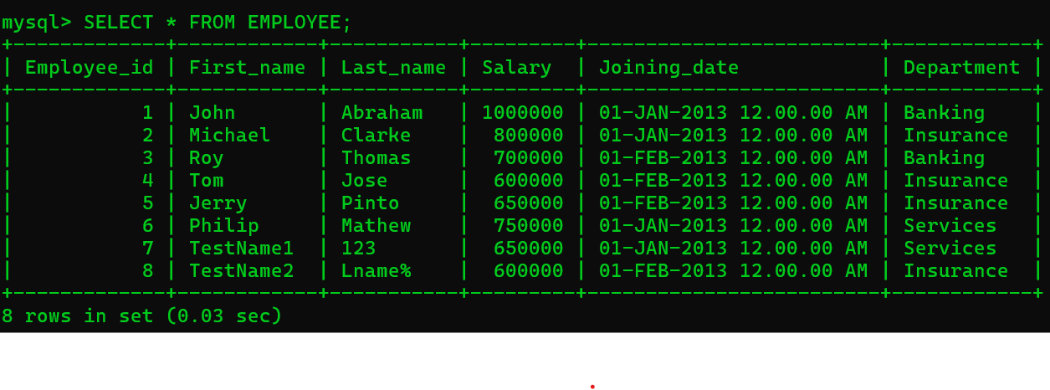

**Table 2 : Incentive**

CREATE TABLE Incentive(

Employee_ref_id INT NOT NULL, FOREIGN KEY(Employee_ref_id) REFERENCES Employee(Employee_id),

Incentive_date VARCHAR(50),

Incentive_amount INT

);

INSERT INTO Incentive VALUES(1, "01-FEB-13", 5000),

(2, "01-FEB-13", 3000),

(3, "01-FEB-13", 4000),

(1, "01-JAN-13", 4500),

(2, "01-JAN-13", 3500);

